# **Flowcharts**

## Various processes to be coded along with their flowchart is as follows :

1. Login Process
   1. Selection as Admin, Teacher, or Student
   2. Provide username and password
   3. Authentication

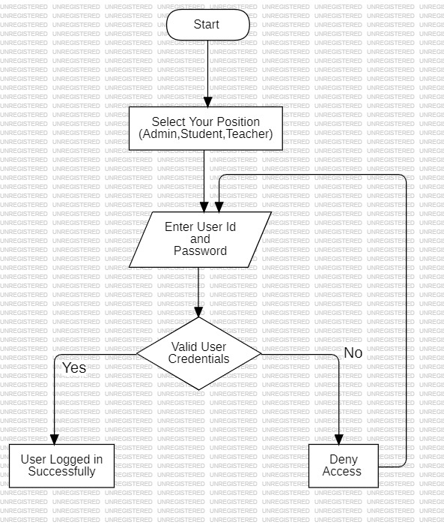

1. Admin Panel
   1. Login
   2. Select to either add course or add teacher

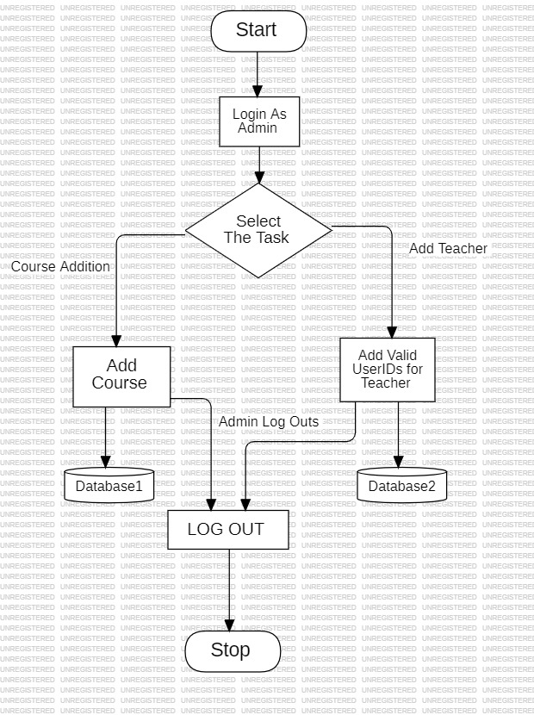

1. Teacher Panel
   1. Login
   2. Select either to add Student or Create Quiz

And follow accordingly as given in flowchart

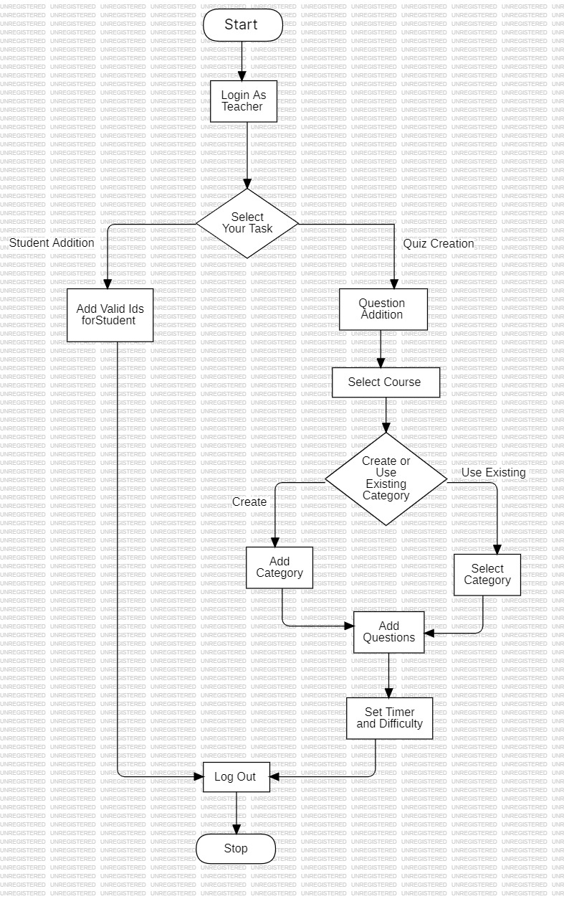

1. Student Panel
   1. Login
   2. Select to Take Quiz or View Progress

And proceed accordingly as in flowchart

